Due to the nature of the total score data not being normally distributed. I think it makes more sense to use the Mann-Whitney U Test to test the differences between demographics.

Testing for Normality:

Using the Shapiro-Wilk test because the sample size is less than 50.

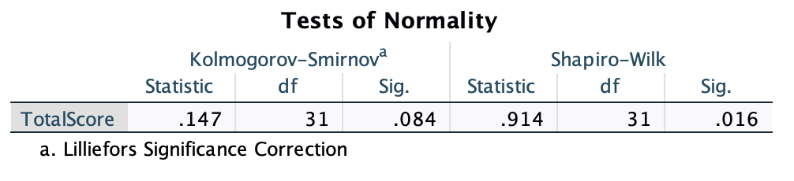

Here the null hypothesis is that there is no difference between the normal distribution and the data. Because the p-value is less than 0.05 that means we reject the null hypothesis. If we reject the null hypothesis, it means the data is not normally distributed (there is a significant difference between the normal and the data distribution).

We can also confirm with a Q-Q plot. The curve is S-shaped and may indicate non-normality.

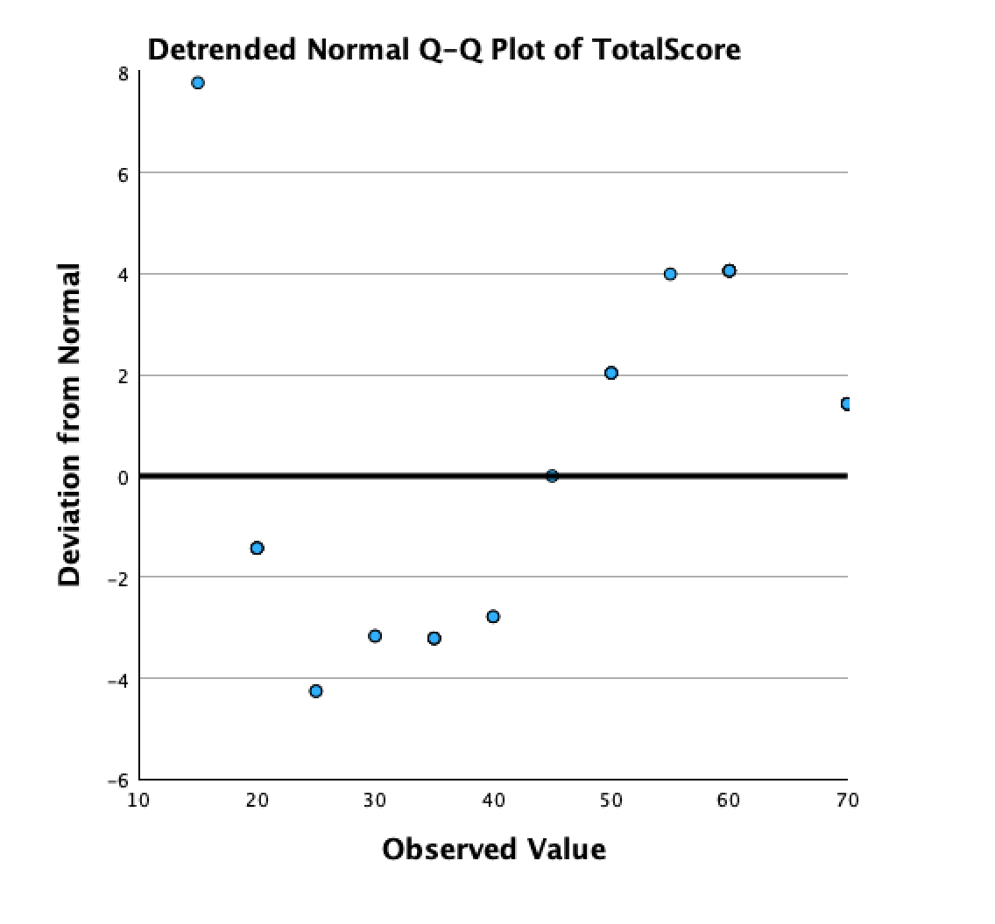

Histogram:

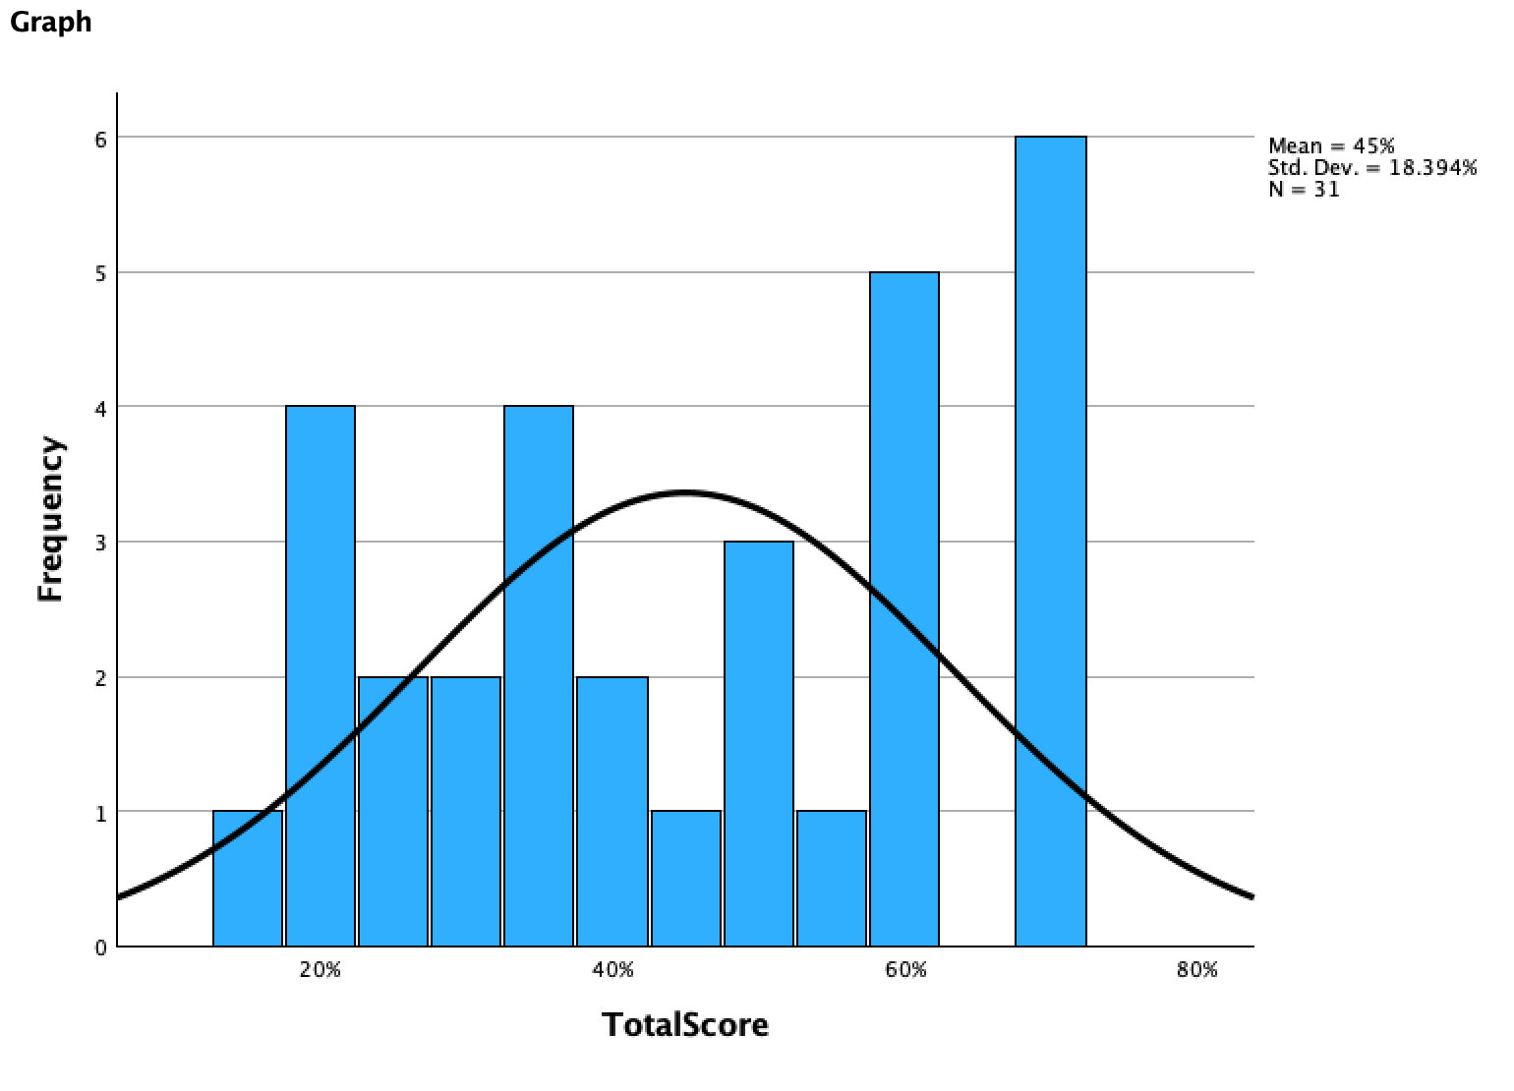

Because the normality test showed the data was not normally distributed, we are going to use non parametric tests. Nonparametric means the statistical method does not assume a specific distribution for the data. This is often used when data is not normally distributed, the sample size is small and the data is ordinal or ranked. Our data is interval/ratio because we are not ranking the scores that students got.

As for skewness and kurtosis, the data is the normal range for skewness at -0.26 and the kurtosis is slightly below - which indicates it is platykurtic distribution (light tails, fewer extreme values). It is a flatter distribution than normal.

Race:

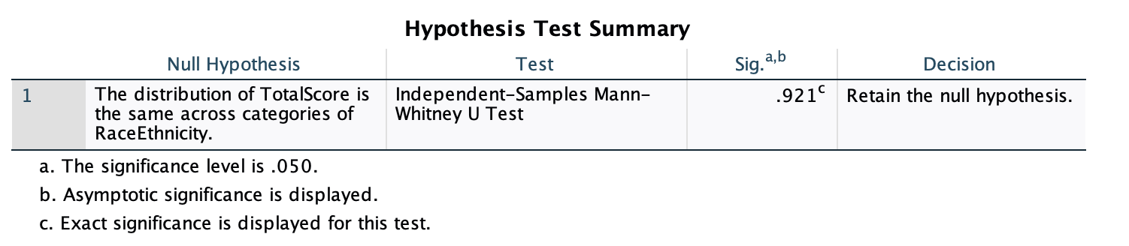

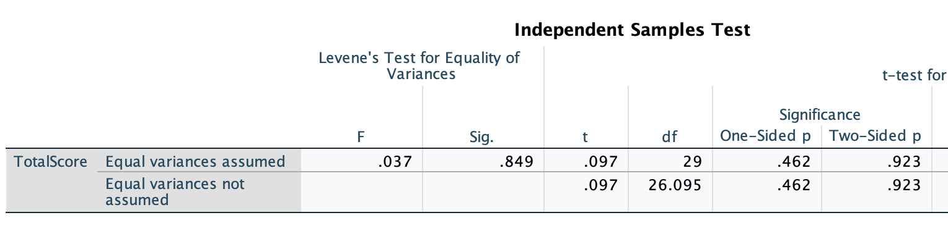

Testing Accommodations:

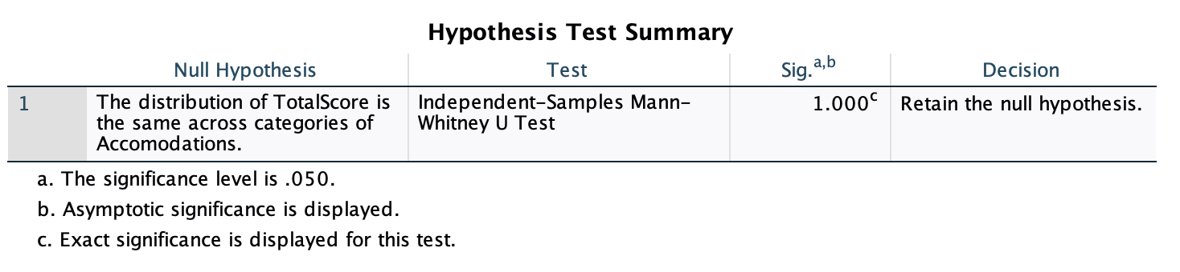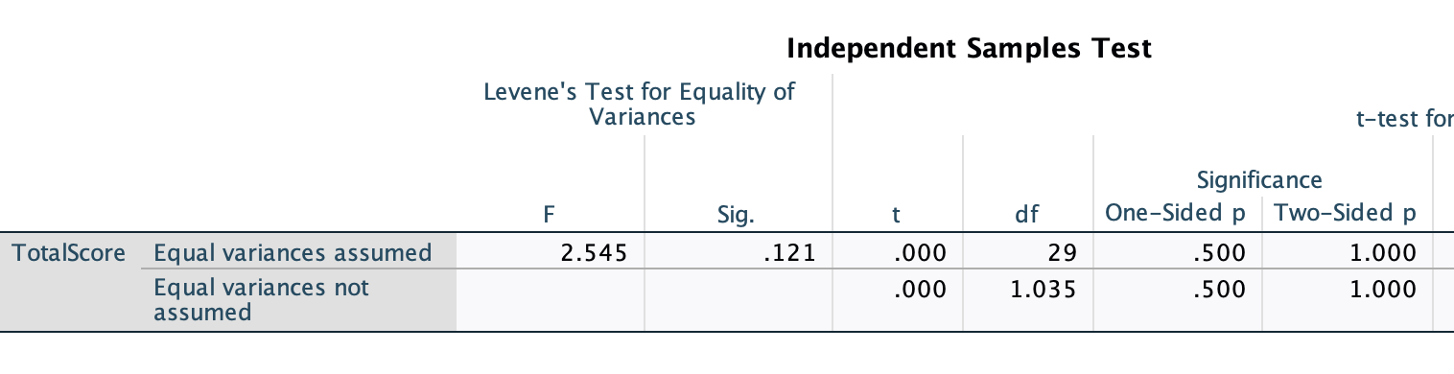

Sex:

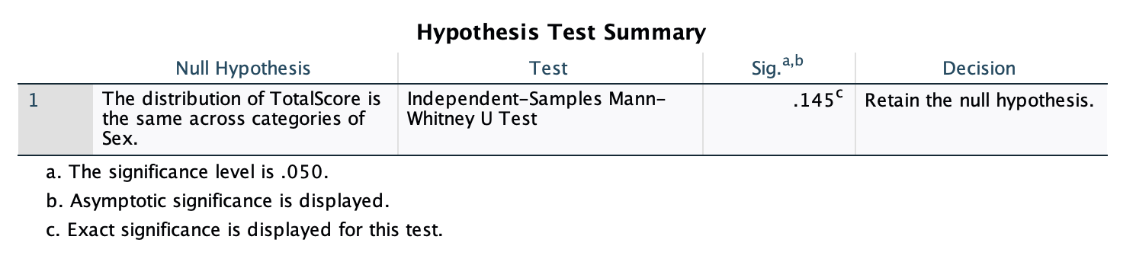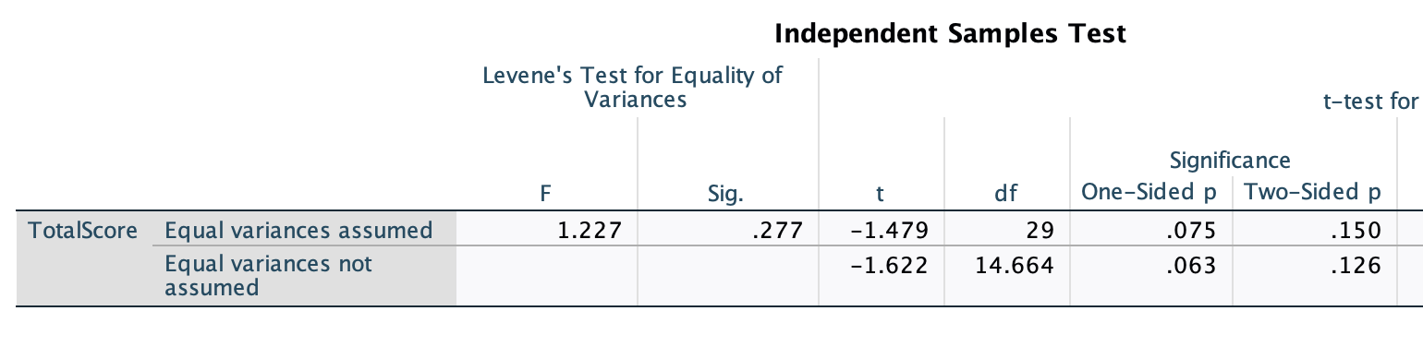

English Proficiency:

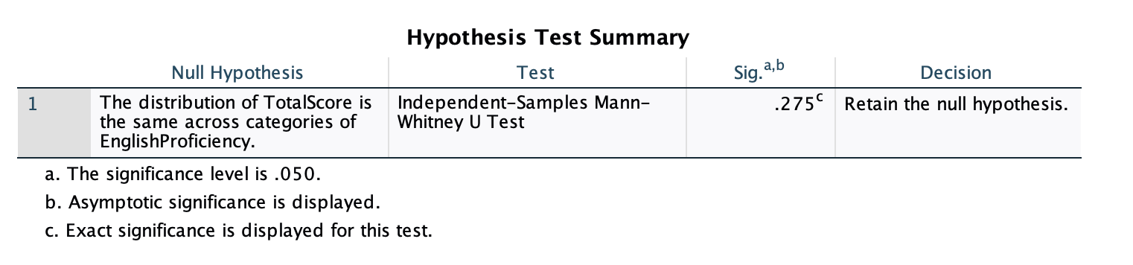

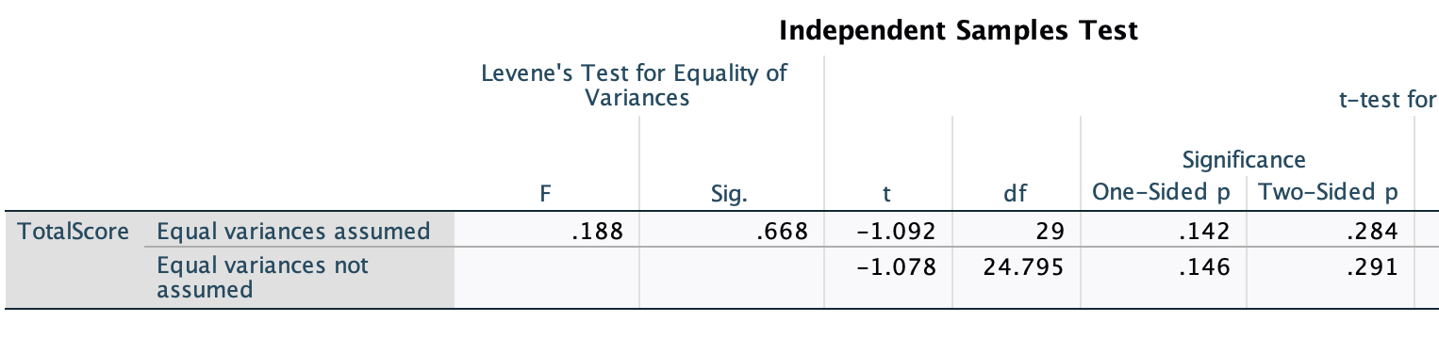

Born in the US: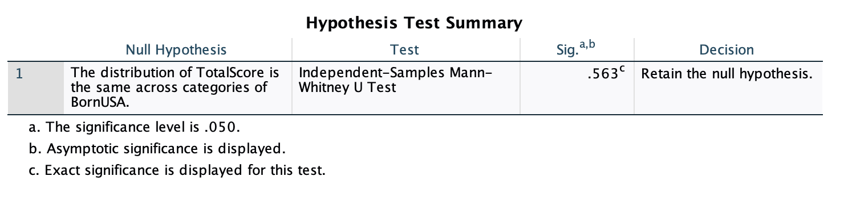

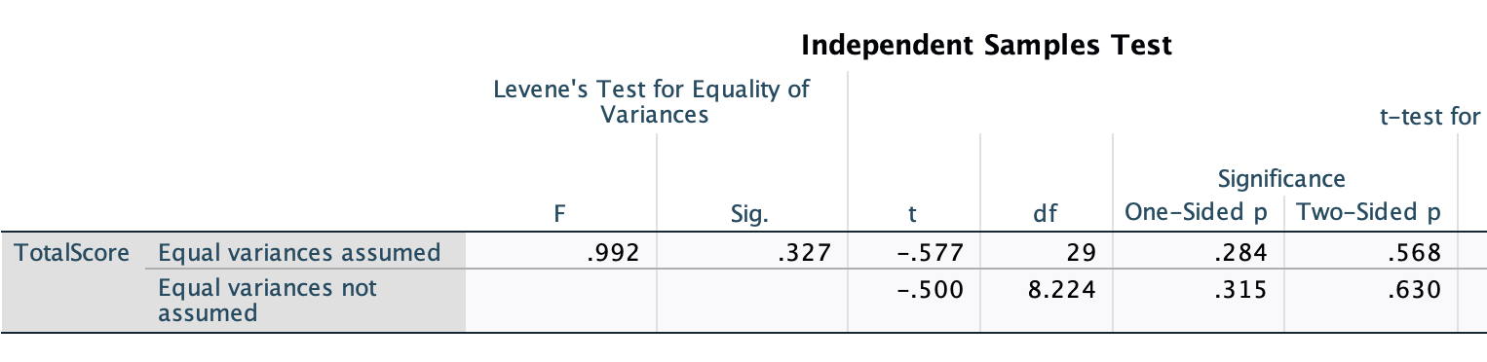

Home Language:

